A

MINOR PROJECT REPORT

ON

__________________________________________________

**COVID-19 TRACKER APPLICATION**

__________________________________________________

SUBMITTED IN THE PARTICULAR FULFILLMENT OF

THE DEGREE OF

**BACHELOR OF COMPUTER APPLICATION**

Dr. B.R Ambedkar University, Agra

BY

ZIBRAN

1805255011074

**

*DEPARTMENT OF COMPUTER APPLICATION*

*MANORAMA INSTITUTE OF MANAGEMENT AND TECHNOLOGY*

*LADAMDA, FATEHPUR SIKRI ROAD, AGRA- 283105*

*Year-2020-21*

**DECLARATION**

I **Zibran S/o Mr. Hafiz Mahmood** a student of Bachelor of Computer Application III Year Roll No- **180525501174** hereby declare that the Project entitled **“Covid-19 Tracker Application”** which is being submitted to the Department of Computer Application, is authentic work carried out at the name of the lab **Manorama Institute of Management & Technology** during my VIth semester.

I declare that the work has not been submitted in part or in full to any other university or institute for the award of any degree or diploma.

DATE: STUDENT

SIGNATURE: Zibran

**ACKNOWLEDGEMENT**

I extend the deep sense of gratitude and sincere thanks to our subject Teacher “**Mr. Harsh Sharma**” for his valuable support and guidance in carrying my project work “**COVID**-**19 TRACKER Application**”. I also express my gratitude to all the faculty members, parents, and my fellow mates who have helped me to carry out this work. Last but not the least, I thank my Almighty God for His blessing showed on me during this period.

Zibran

**CERTIFICATE**

This is to certify that “**Zibran**” student of Bachelor of Computer Application III Year Roll No- **180525501174** has completed their “**COVID**-**19 TRACKER Application**” project under the guidance of “**Mr. Harsh Sharma**”.

**Mr.Harsh Sharma**

**INDEX**

|  |  |  |  |
| --- | --- | --- | --- |
| S.NO | TOPIC NAME | DATE | SIGNATURE |
| 1  2  3  4  5  6  7  8  9  10  11 | Introduction  System requirement specification  Application requirement specification  Use case Model  API references  Splash Screen  Home Screen  Affected Countries  Country Details Screen  Track state  Find vaccination centers |  |  |

**INTRODUCTION**

**The Covid**-**19 Tracker: -** As the virus that causes Covid-19 spreads worldwide, this dashboard offers a snapshot of the crisis right now. Click on a country name to get a more detailed geographic breakdown at the state, province, or county level. Please note that because of limited testing capacity in some areas, the actual number of cases is believed to be higher.

You can look at the rolling average of new cases over a selected range of time to get a far more robust sense of the trends in any given location. You can also view the rate of infection and deaths.

**Covid-19 Tracker can help to Check Your Nearest Vaccination Center And Slots Availability. Search by PIN.**

A list with the name of hospitals and vaccination centers will appear with the address of the center.

**SYSTEM REQUIREMENT SPECIFICATION**

**Operating Systems**: Microsoft Window

**Technologies Used**:

* Front End: XML(extensible markup language )
* Back end language: Java
* API (Application Programming Interface)

**Software Requirements**:

* Android Studio
* Postman

**Hardware Requirements**:

**Windows**

* 64-bit Microsoft® Windows® 8/10
* x86_64 CPU architecture; 2nd generation Intel Core or newer, or AMD CPU with support for a [Windows Hypervisor](https://developer.android.com/studio/run/emulator-acceleration#vm-windows)
* 8 GB RAM or more
* 8 GB of available disk space minimum (IDE + Android SDK + Android Emulator)
* 1280 x 800 minimum screen resolution

**Application requirements:**

**Hardware Requirement:-**

* Qualcomm: Snap, the Mighty Dragon, or similar processor-based Mobile at Client/Server end.
* 128 MB RAM and 4GB Internal space (for Database) is desirable.
* Local Area Network(LAN) is required for Client-Server Installation

**Software Requirement-**

* Minimum Android version 5.0 Lollipop.

**USE CASE MODEL**

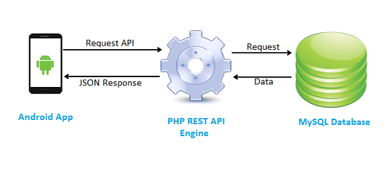

**API: -**

A REST API (also known as RESTful API) is an application programming interface (API or web API) **that conforms to the constraints of REST architectural style and allows for interaction with RESTful web services**. REST stands for representational state transfer and was created by computer scientist Roy Fielding.

**API references:-**

This API shows global statistics of covid-19 cases

* <https://corona.lmao.ninja/v2/all/>

This API shows states of India only of covid-19 cases.

* <https://api.rootnet.in/covid19-in/stats/latest>

This API shows the vaccination centers of Indian states according to the Pin code.

* <https://cdnapi.covin.in/api/v2/appointment/sessions/public/findByPin?pincode=282010&date=27-08-2021>

.

**SPLASH SCREEN**

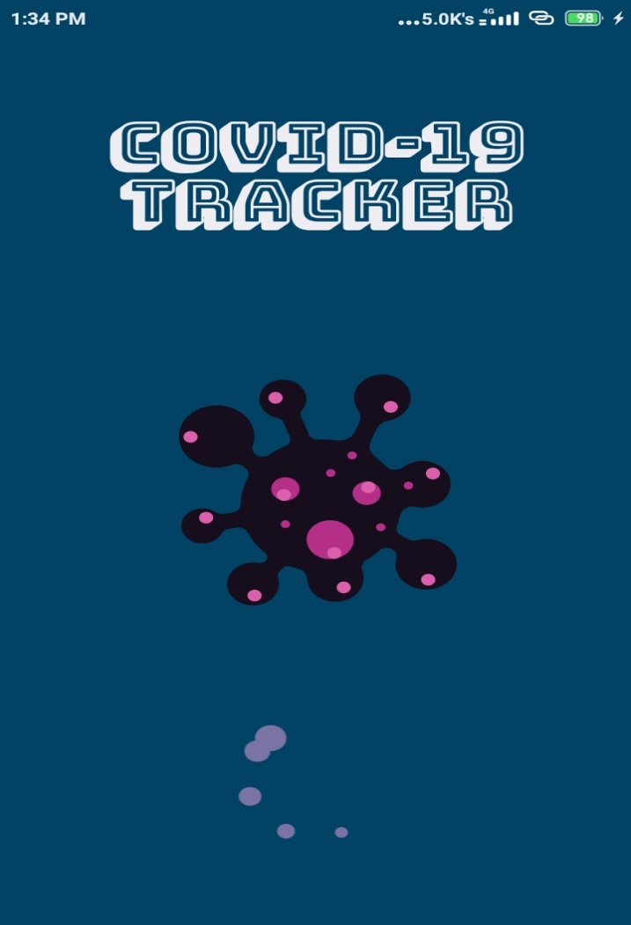

**Splash Screen:-**This is the first screen of our App, which is called Splash Screen.

Whenever we start our App this screen will be shown.

**XML Front end Code of this Splash Screen:-**

<?xml version="1.0" encoding="utf-8"?>  
<androidx.constraintlayout.widget.ConstraintLayout xmlns:android="http://schemas.android.com/apk/res/android"  
 xmlns:app="http://schemas.android.com/apk/res-auto"  
 xmlns:tools="http://schemas.android.com/tools"  
 android:layout_width="match_parent"  
 android:layout_height="match_parent"  
 android:background="@color/colorPrimary"  
 tools:context=".SplashActivity">  
  
 <com.airbnb.lottie.LottieAnimationView  
 android:id="@+id/lottie_home"  
 android:layout_width="match_parent"  
 android:layout_height="200sp"  
 android:layout_marginTop="50dp"  
 app:layout_constraintBottom_toTopOf="@+id/lottie_home2"  
 app:layout_constraintEnd_toEndOf="parent"  
 app:layout_constraintHorizontal_bias="0.0"  
 app:layout_constraintStart_toStartOf="parent"  
 app:lottie_autoPlay="true"  
 app:lottie_fileName="2147-virus-cell.json"  
 app:lottie_loop="true" />  
  
 <TextView  
 android:layout_width="match_parent"  
 android:layout_height="wrap_content"  
 android:fontFamily="@font/bungee_shade"  
 android:gravity="center"  
 android:text="@string/app_name"  
 android:textColor="@color/color_white"  
 android:textSize="40sp"  
 android:textStyle="bold"  
 app:layout_constraintBottom_toTopOf="@+id/lottie_home"  
 app:layout_constraintEnd_toEndOf="parent"  
 app:layout_constraintStart_toStartOf="parent"  
 app:layout_constraintTop_toTopOf="parent" />  
  
 <com.airbnb.lottie.LottieAnimationView  
 android:id="@+id/lottie_home2"  
 android:layout_width="match_parent"  
 android:layout_height="200sp"  
 app:layout_constraintBottom_toBottomOf="parent"  
 app:layout_constraintEnd_toEndOf="parent"  
 app:layout_constraintHorizontal_bias="0.0"  
 app:layout_constraintStart_toStartOf="parent"  
 app:lottie_autoPlay="true"  
 app:lottie_fileName="8707-loading.json"  
 app:lottie_loop="true" />  
  
</androidx.constraintlayout.widget.ConstraintLayout>

**Java Back end Code of this Splash Screen:-**

package com.zibran.covid19tracker**;**import androidx.appcompat.app.AppCompatActivity**;**import android.content.Intent**;**import android.os.Bundle**;**import android.os.Handler**;**import android.view.WindowManager**;**import java.util.Objects**;**public class SplashActivity extends AppCompatActivity {  
  
 @Override  
 protected void onCreate(Bundle savedInstanceState) {  
 super.onCreate(savedInstanceState)**;** setContentView(R.layout.activity_splash)**;** getWindow().setFlags(WindowManager.LayoutParams.FLAG_LAYOUT_NO_LIMITS**,**WindowManager.LayoutParams.FLAG_LAYOUT_NO_LIMITS)**;** Objects.requireNonNull(getSupportActionBar()).hide()**;** new Handler().postDelayed(() -> {  
 Intent intent = new Intent(getApplicationContext()**,**MainActivity.class)**;** startActivity(intent)**;** finish()**;** }**,4000**)**;** }  
}

**HOME SCREEN**

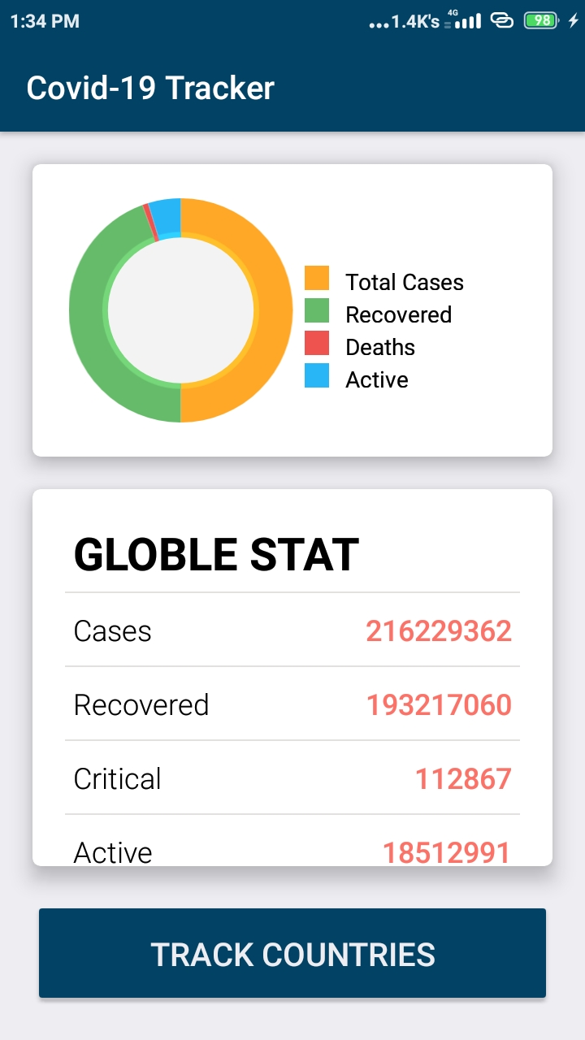

**About Home Screen:-**

This screen shows the total global Covid-19 cases. There is a pie chart in this screen which is on the top of this screen which shows :

* **Total Cases:-** This states that how many covid-19 casesare there in the world.
* **Recovered:-** This states that how many covid-19 cases have been recovered in the World.
* **Deaths:-** This states that how many deaths have occurred in the world due to covid-19.
* **Active:** This states that how many covid-19 cases are active in the world.

**Globe Statistics:-**

This shows the statistics of all covid-19 cases.

* **Cases:-** This states in figures that how many covid-19 cases are there in the world.
* **Recovered:-** This states in figures that how many covid-19 cases have been recovered in the world.
* **Critical:-** This states in figures that how many covid-19 cases are Critical in the world.
* **Active:-** This states in figures that how many covid-19 cases are active in the world.
* **Today Cases:-** This states in figures that how many covid-19 cases are active today in the world.
* **Total Deaths:-** This states in figures that total how many deaths in the world due to covid.
* **Today Deaths:-** This states in figures that today how many deaths in the world due to covid.
* **Affected Countries:-**This states in figures that how many countries are affected by covid in the world.

**Track Countries:-**

At the bottom of this screen, there is a button that tracks the countries of the world. This states that how many covid cases are there in which country.

**Front end Xml code of Home Screen:-**

<?xml version="1.0" encoding="utf-8"?>  
<RelativeLayout xmlns:android="http://schemas.android.com/apk/res/android"  
 xmlns:app="http://schemas.android.com/apk/res-auto"  
 xmlns:tools="http://schemas.android.com/tools"  
 android:layout_width="match_parent"  
 android:layout_height="match_parent"  
 android:background="@color/color_white"  
 tools:context=".MainActivity">  
  
 <androidx.cardview.widget.CardView  
 android:id="@+id/cardViewGraph"  
 android:layout_width="match_parent"  
 android:layout_height="180sp"  
 android:layout_marginLeft="20sp"  
 android:layout_marginTop="20sp"  
 android:layout_marginRight="20sp"  
 app:cardCornerRadius="5dp"  
 app:cardElevation="10dp">  
  
 <LinearLayout  
 android:layout_width="match_parent"  
 android:layout_height="match_parent"  
 android:orientation="horizontal"  
 android:weightSum="2">  
  
 <org.eazegraph.lib.charts.PieChart  
 android:id="@+id/piechart"  
 android:layout_width="0dp"  
 android:layout_height="match_parent"  
 android:layout_marginStart="15dp"  
 android:layout_marginTop="15dp"  
 android:layout_marginBottom="15dp"  
 android:layout_weight="1"  
 android:padding="6dp" />  
  
 <LinearLayout  
 android:layout_width="0dp"  
 android:layout_height="match_parent"  
 android:layout_marginTop="20dp"  
 android:layout_weight="1"  
 android:gravity="center_vertical"  
 android:orientation="vertical">  
  
 <LinearLayout  
 android:layout_width="match_parent"  
 android:layout_height="15dp"  
 android:gravity="center_vertical">  
  
 <View  
 android:layout_width="15dp"  
 android:layout_height="match_parent"  
 android:background="@color/cases" />  
  
 <TextView  
 android:layout_width="wrap_content"  
 android:layout_height="wrap_content"  
 android:paddingStart="10dp"  
 android:text="@string/total_cases"  
 android:textColor="@color/color_black"  
 tools:ignore="RtlSymmetry" />  
  
 </LinearLayout>  
  
 <LinearLayout  
 android:layout_width="match_parent"  
 android:layout_height="15dp"  
 android:layout_marginTop="5dp"  
 android:gravity="center_vertical">  
  
 <View  
 android:layout_width="15dp"  
 android:layout_height="match_parent"  
 android:background="@color/recovered" />  
  
 <TextView  
 android:layout_width="wrap_content"  
 android:layout_height="wrap_content"  
 android:paddingStart="10dp"  
 android:text="@string/recovered"  
 android:textColor="@color/color_black"  
 tools:ignore="RtlSymmetry" />  
  
 </LinearLayout>  
  
 <LinearLayout  
 android:layout_width="match_parent"  
 android:layout_height="15dp"  
 android:layout_marginTop="5dp"  
 android:gravity="center_vertical">  
  
 <View  
 android:layout_width="15dp"  
 android:layout_height="match_parent"  
 android:background="@color/deaths" />  
  
 <TextView  
 android:layout_width="wrap_content"  
 android:layout_height="wrap_content"  
 android:paddingStart="10dp"  
 android:text="@string/deaths"  
 android:textColor="@color/color_black"  
 tools:ignore="RtlSymmetry" />  
  
 </LinearLayout>  
  
 <LinearLayout  
 android:layout_width="match_parent"  
 android:layout_height="15dp"  
 android:layout_marginTop="5dp"  
 android:gravity="center_vertical">  
  
 <View  
 android:layout_width="15dp"  
 android:layout_height="match_parent"  
 android:background="@color/active" />  
  
 <TextView  
 android:layout_width="wrap_content"  
 android:layout_height="wrap_content"  
 android:paddingStart="10dp"  
 android:text="Active"  
 android:textColor="@color/color_black" />  
  
 </LinearLayout>  
 </LinearLayout>  
 </LinearLayout>  
  
  
 </androidx.cardview.widget.CardView>  
  
 <androidx.cardview.widget.CardView  
 android:layout_width="match_parent"  
 android:layout_height="fill_parent"  
 android:layout_above="@+id/btnTrack"  
 android:layout_below="@id/cardViewGraph"  
 android:layout_marginLeft="20sp"  
 android:layout_marginTop="20sp"  
 android:layout_marginRight="20sp"  
 app:cardCornerRadius="5dp"  
 app:cardElevation="10dp">  
  
 <RelativeLayout  
 android:layout_width="match_parent"  
 android:layout_height="match_parent">  
  
 <com.leo.simplearcloader.SimpleArcLoader  
 android:id="@+id/loader"  
 android:layout_width="60dp"  
 android:layout_height="60dp"  
 android:layout_centerInParent="true"  
 android:visibility="visible"  
 app:arc_style="simple_arc"></com.leo.simplearcloader.SimpleArcLoader>  
  
 <ScrollView  
 android:id="@+id/scrollStates"  
 android:layout_width="match_parent"  
 android:layout_height="match_parent"  
 android:visibility="gone">  
  
 <LinearLayout  
 android:layout_width="match_parent"  
 android:layout_height="wrap_content"  
 android:orientation="vertical">  
  
 <TextView  
 android:layout_width="match_parent"  
 android:layout_height="wrap_content"  
 android:layout_marginLeft="25dp"  
 android:layout_marginTop="20dp"  
 android:text="Globle Stat"  
 android:textAllCaps="true"  
 android:textColor="@color/color_black"  
 android:textSize="28sp"  
 android:textStyle="bold" />  
  
 <View  
 android:layout_width="match_parent"  
 android:layout_height="1dp"  
 android:layout_marginLeft="20dp"  
 android:layout_marginTop="5dp"  
 android:layout_marginRight="20dp"  
 android:background="@color/color_two" />  
  
 <RelativeLayout  
 android:layout_width="match_parent"  
 android:layout_height="wrap_content"  
 android:layout_marginLeft="25dp"  
 android:layout_marginTop="10dp"  
 android:layout_marginRight="25dp"  
 android:layout_marginBottom="10dp">  
  
 <TextView  
 android:layout_width="wrap_content"  
 android:layout_height="wrap_content"  
 android:fontFamily="sans-serif-light"  
 android:text="Cases"  
 android:textColor="@color/color_black"  
 android:textSize="18sp" />  
  
 <TextView  
 android:id="@+id/tvCases"  
 android:layout_width="fill_parent"  
 android:layout_height="wrap_content"  
 android:layout_alignParentRight="true"  
 android:fontFamily="sans-serif-light"  
 android:text="0"  
 android:textAlignment="textEnd"  
 android:textColor="@color/color_one"  
 android:textSize="18sp"  
 android:textStyle="bold" />  
  
 </RelativeLayout>  
  
 <View  
 android:layout_width="match_parent"  
 android:layout_height="1dp"  
 android:layout_marginLeft="20dp"  
 android:layout_marginRight="20dp"  
 android:background="@color/color_two" />  
  
 <RelativeLayout  
 android:layout_width="match_parent"  
 android:layout_height="wrap_content"  
 android:layout_marginLeft="25dp"  
 android:layout_marginTop="10dp"  
 android:layout_marginRight="25dp"  
 android:layout_marginBottom="10dp">  
  
 <TextView  
 android:layout_width="wrap_content"  
 android:layout_height="wrap_content"  
 android:fontFamily="sans-serif-light"  
 android:text="Recovered"  
 android:textColor="@color/color_black"  
 android:textSize="18sp" />  
  
 <TextView  
 android:id="@+id/tvRecovered"  
 android:layout_width="fill_parent"  
 android:layout_height="wrap_content"  
 android:layout_alignParentRight="true"  
 android:fontFamily="sans-serif-light"  
 android:text="0"  
 android:textAlignment="textEnd"  
 android:textColor="@color/color_one"  
 android:textSize="18sp"  
 android:textStyle="bold" />  
  
 </RelativeLayout>  
  
 <View  
 android:layout_width="match_parent"  
 android:layout_height="1dp"  
 android:layout_marginLeft="20dp"  
 android:layout_marginRight="20dp"  
 android:background="@color/color_two" />  
  
 <RelativeLayout  
 android:layout_width="match_parent"  
 android:layout_height="wrap_content"  
 android:layout_marginLeft="25dp"  
 android:layout_marginTop="10dp"  
 android:layout_marginRight="25dp"  
 android:layout_marginBottom="10dp">  
  
 <TextView  
 android:layout_width="wrap_content"  
 android:layout_height="wrap_content"  
 android:fontFamily="sans-serif-light"  
 android:text="Critical"  
 android:textColor="@color/color_black"  
  
 android:textSize="18sp" />  
  
 <TextView  
 android:id="@+id/tvCritical"  
 android:layout_width="fill_parent"  
 android:layout_height="wrap_content"  
 android:layout_alignParentRight="true"  
 android:fontFamily="sans-serif-light"  
 android:text="0"  
 android:textAlignment="textEnd"  
 android:textColor="@color/color_one"  
 android:textSize="18sp"  
 android:textStyle="bold" />  
  
 </RelativeLayout>  
  
 <View  
 android:layout_width="match_parent"  
 android:layout_height="1dp"  
 android:layout_marginLeft="20dp"  
 android:layout_marginRight="20dp"  
 android:background="@color/color_two" />  
  
 <RelativeLayout  
 android:layout_width="match_parent"  
 android:layout_height="wrap_content"  
 android:layout_marginLeft="25dp"  
 android:layout_marginTop="10dp"  
 android:layout_marginRight="25dp"  
 android:layout_marginBottom="10dp">  
  
 <TextView  
 android:layout_width="wrap_content"  
 android:layout_height="wrap_content"  
 android:fontFamily="sans-serif-light"  
 android:text="Active"  
 android:textColor="@color/color_black"  
  
 android:textSize="18sp" />  
  
 <TextView  
 android:id="@+id/tvActive"  
 android:layout_width="fill_parent"  
 android:layout_height="wrap_content"  
 android:layout_alignParentRight="true"  
 android:fontFamily="sans-serif-light"  
 android:text="0"  
 android:textAlignment="textEnd"  
 android:textColor="@color/color_one"  
 android:textSize="18sp"  
 android:textStyle="bold" />  
  
 </RelativeLayout>  
  
 <View  
 android:layout_width="match_parent"  
 android:layout_height="1dp"  
 android:layout_marginLeft="20dp"  
 android:layout_marginRight="20dp"  
 android:background="@color/color_two" />  
  
 <RelativeLayout  
 android:layout_width="match_parent"  
 android:layout_height="wrap_content"  
 android:layout_marginLeft="25dp"  
 android:layout_marginTop="10dp"  
 android:layout_marginRight="25dp"  
 android:layout_marginBottom="10dp">  
  
 <TextView  
 android:layout_width="wrap_content"  
 android:layout_height="wrap_content"  
 android:fontFamily="sans-serif-light"  
 android:text="Today Cases"  
 android:textColor="@color/color_black"  
  
 android:textSize="18sp" />  
  
 <TextView  
 android:id="@+id/tvTodayCases"  
 android:layout_width="fill_parent"  
 android:layout_height="wrap_content"  
 android:layout_alignParentRight="true"  
 android:fontFamily="sans-serif-light"  
 android:text="0"  
 android:textAlignment="textEnd"  
 android:textColor="@color/color_one"  
 android:textSize="18sp"  
 android:textStyle="bold" />  
  
 </RelativeLayout>  
  
 <View  
 android:layout_width="match_parent"  
 android:layout_height="1dp"  
 android:layout_marginLeft="20dp"  
 android:layout_marginRight="20dp"  
 android:background="@color/color_two" />  
  
 <RelativeLayout  
 android:layout_width="match_parent"  
 android:layout_height="wrap_content"  
 android:layout_marginLeft="25dp"  
 android:layout_marginTop="10dp"  
 android:layout_marginRight="25dp"  
 android:layout_marginBottom="10dp">  
  
 <TextView  
 android:layout_width="wrap_content"  
 android:layout_height="wrap_content"  
 android:fontFamily="sans-serif-light"  
 android:text="Total Deaths"  
 android:textColor="@color/color_black"  
  
 android:textSize="18sp" />  
  
 <TextView  
 android:id="@+id/tvTotalDeaths"  
 android:layout_width="fill_parent"  
 android:layout_height="wrap_content"  
 android:layout_alignParentRight="true"  
 android:fontFamily="sans-serif-light"  
 android:text="0"  
 android:textAlignment="textEnd"  
 android:textColor="@color/color_one"  
 android:textSize="18sp"  
 android:textStyle="bold" />  
  
 </RelativeLayout>  
  
 <View  
 android:layout_width="match_parent"  
 android:layout_height="1dp"  
 android:layout_marginLeft="20dp"  
 android:layout_marginRight="20dp"  
 android:background="@color/color_two" />  
  
 <RelativeLayout  
 android:layout_width="match_parent"  
 android:layout_height="wrap_content"  
 android:layout_marginLeft="25dp"  
 android:layout_marginTop="10dp"  
 android:layout_marginRight="25dp"  
 android:layout_marginBottom="10dp">  
  
 <TextView  
 android:layout_width="wrap_content"  
 android:layout_height="wrap_content"  
 android:fontFamily="sans-serif-light"  
 android:text="Today Deaths"  
 android:textColor="@color/color_black"  
  
 android:textSize="18sp" />  
  
 <TextView  
 android:id="@+id/tvTodayDeaths"  
 android:layout_width="fill_parent"  
 android:layout_height="wrap_content"  
 android:layout_alignParentRight="true"  
 android:fontFamily="sans-serif-light"  
 android:text="0"  
 android:textAlignment="textEnd"  
 android:textColor="@color/color_one"  
 android:textSize="18sp"  
 android:textStyle="bold" />  
  
 </RelativeLayout>  
  
 <View  
 android:layout_width="match_parent"  
 android:layout_height="1dp"  
 android:layout_marginLeft="20dp"  
 android:layout_marginRight="20dp"  
 android:background="@color/color_two" />  
  
 <RelativeLayout  
 android:layout_width="match_parent"  
 android:layout_height="wrap_content"  
 android:layout_marginLeft="25dp"  
 android:layout_marginTop="10dp"  
 android:layout_marginRight="25dp"  
 android:layout_marginBottom="10dp">  
  
 <TextView  
 android:layout_width="wrap_content"  
 android:layout_height="wrap_content"  
 android:fontFamily="sans-serif-light"  
 android:text="Affected Countries"  
 android:textColor="@color/color_black"  
  
 android:textSize="18sp" />  
  
 <TextView  
 android:id="@+id/tvAffectedCountries"  
 android:layout_width="fill_parent"  
 android:layout_height="wrap_content"  
 android:layout_alignParentRight="true"  
 android:fontFamily="sans-serif-light"  
 android:text="0"  
 android:textAlignment="textEnd"  
 android:textColor="@color/color_one"  
 android:textSize="18sp"  
 android:textStyle="bold" />  
  
 </RelativeLayout>  
  
 <View  
 android:layout_width="match_parent"  
 android:layout_height="1dp"  
 android:layout_marginLeft="20dp"  
 android:layout_marginRight="20dp"  
 android:background="@color/color_two" />  
  
 </LinearLayout>  
  
  
 </ScrollView>  
 </RelativeLayout>  
  
  
 </androidx.cardview.widget.CardView>  
  
 <Button  
 android:id="@+id/btnTrack"  
 android:layout_width="match_parent"  
 android:layout_height="wrap_content"  
 android:layout_alignParentBottom="true"  
 android:layout_marginStart="20sp"  
 android:layout_marginTop="20sp"  
 android:layout_marginEnd="20sp"  
 android:layout_marginBottom="20sp"  
 android:backgroundTint="@color/colorPrimary"  
 android:onClick="goTrackCountries"  
 android:text="@string/track_countries"  
 android:textColor="@color/color_white"  
 android:elevation="3dp"  
 android:textSize="20sp"  
 android:padding="20dp"  
 tools:targetApi="lollipop" />  
  
</RelativeLayout>

**Java Back end Code of this Home Screen:-**

package com.zibran.covid19tracker**;**import androidx.appcompat.app.AppCompatActivity**;**import android.content.Intent**;**import android.graphics.Color**;**import android.os.Bundle**;**import android.view.View**;**import android.view.WindowManager**;**import android.widget.ScrollView**;**import android.widget.TextView**;**import android.widget.Toast**;**import com.android.volley.Request**;**import com.android.volley.RequestQueue**;**import com.android.volley.Response**;**import com.android.volley.VolleyError**;**import com.android.volley.toolbox.StringRequest**;**import com.android.volley.toolbox.Volley**;**import com.leo.simplearcloader.SimpleArcLoader**;**import org.eazegraph.lib.charts.PieChart**;**import org.eazegraph.lib.models.PieModel**;**import org.json.JSONException**;**import org.json.JSONObject**;**public class MainActivity extends AppCompatActivity {  
  
 TextView tvCases**,** tvRecovered**,** tvCritical**,** tvActive**,** tvTodayCases**,** tvTotalDeaths**,** tvTodayDeaths**,** tvAffectiveCountries**;** SimpleArcLoader simpleArcLoader**;** ScrollView scrollView**;** PieChart pieChart**;** @Override  
 protected void onCreate(Bundle savedInstanceState) {  
 super.onCreate(savedInstanceState)**;** setContentView(R.layout.*activity_main*)**;** tvCases = findViewById(R.id.*tvCases*)**;** tvRecovered = findViewById(R.id.*tvRecovered*)**;** tvCritical = findViewById(R.id.*tvCritical*)**;** tvActive = findViewById(R.id.*tvActive*)**;** tvTodayCases = findViewById(R.id.*tvTodayCases*)**;** tvTotalDeaths = findViewById(R.id.*tvTotalDeaths*)**;** tvTodayDeaths = findViewById(R.id.*tvTodayDeaths*)**;** tvAffectiveCountries = findViewById(R.id.*tvAffectedCountries*)**;** simpleArcLoader = findViewById(R.id.*loader*)**;** scrollView = findViewById(R.id.*scrollStates*)**;** pieChart = findViewById(R.id.*piechart*)**;** fetchData()**;** }  
  
 private void fetchData() {  
  
 String url = "https://corona.lmao.ninja/v2/all/"**;** simpleArcLoader.start()**;** StringRequest request = new StringRequest(Request.Method.*GET***,** url**,** response -> {  
  
 try {  
 JSONObject jsonObject = new JSONObject(response)**;** tvCases.setText(jsonObject.getString("cases"))**;** tvRecovered.setText(jsonObject.getString("recovered"))**;** tvCritical.setText(jsonObject.getString("critical"))**;** tvActive.setText(jsonObject.getString("active"))**;** tvTodayCases.setText(jsonObject.getString("todayCases"))**;** tvTotalDeaths.setText(jsonObject.getString("deaths"))**;** tvTodayDeaths.setText(jsonObject.getString("todayDeaths"))**;** tvAffectiveCountries.setText(jsonObject.getString("affectedCountries"))**;** pieChart.addPieSlice(new PieModel("Cases"**,** Integer.*parseInt*(tvCases.getText().toString())**,** Color.*parseColor*("#FFA726")))**;** pieChart.addPieSlice(new PieModel("Recovered"**,** Integer.*parseInt*(tvRecovered.getText().toString())**,** Color.*parseColor*("#66bb6a")))**;** pieChart.addPieSlice(new PieModel("Deaths"**,** Integer.*parseInt*(tvTotalDeaths.getText().toString())**,** Color.*parseColor*("#ef5350")))**;** pieChart.addPieSlice(new PieModel("Active"**,** Integer.*parseInt*(tvActive.getText().toString())**,** Color.*parseColor*("#29B6F6")))**;** pieChart.startAnimation()**;** simpleArcLoader.stop()**;** simpleArcLoader.setVisibility(View.*GONE*)**;** scrollView.setVisibility(View.*VISIBLE*)**;** } catch (JSONException e) {  
 e.printStackTrace()**;** simpleArcLoader.stop()**;** simpleArcLoader.setVisibility(View.*GONE*)**;** scrollView.setVisibility(View.*VISIBLE*)**;** }  
 }**,** error -> {  
 simpleArcLoader.stop()**;** simpleArcLoader.setVisibility(View.*GONE*)**;** scrollView.setVisibility(View.*VISIBLE*)**;** Toast.*makeText*(MainActivity.this**,** error.getMessage()**,** Toast.*LENGTH_SHORT*).show()**;** })**;** RequestQueue requestQueue = Volley.*newRequestQueue*(this)**;** requestQueue.add(request)**;** }  
  
 public void goTrackCountries(View view) {  
  
 startActivity(new Intent(getApplicationContext()**,** AffectedCountries.class))**;** }  
}

**AFFECTED COUNTRIES**

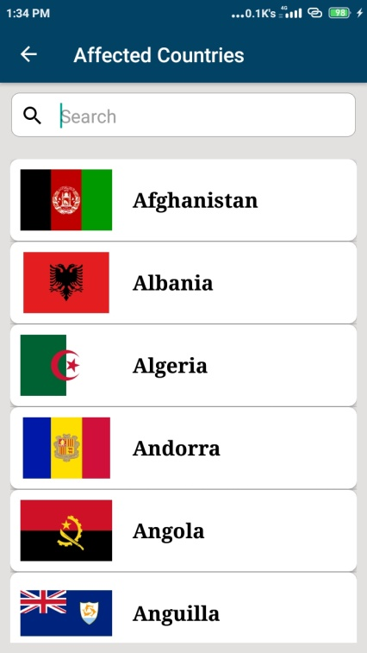

Here you can search any country in which you want to see how many cases are there in the country in the figure.

**Front end Code XML of Affected Countries:**

<?xml version="1.0" encoding="utf-8"?>  
<RelativeLayout xmlns:android="http://schemas.android.com/apk/res/android"  
 xmlns:app="http://schemas.android.com/apk/res-auto"  
 xmlns:tools="http://schemas.android.com/tools"  
 android:layout_width="match_parent"  
 android:background="@color/color_two"  
 android:layout_height="match_parent"  
 tools:context=".AffectedCountries">  
  
  
 <EditText  
 android:layout_width="match_parent"  
 android:layout_height="45dp"  
 android:id="@+id/edtSearch"  
 android:layout_margin="10dp"  
 android:maxLines="1"  
 android:singleLine="true"  
 android:paddingStart="10sp"  
 android:hint="@string/search"  
 android:inputType="textAutoCorrect"  
 android:drawablePadding="15dp"  
 android:background="@drawable/edittext_shadow"  
 android:drawableStart="@drawable/ic_search_black_24dp"  
 android:autofillHints="India"  
 tools:ignore="RtlSymmetry" />  
 <ListView  
 android:id="@+id/listView"  
 android:layout_width="match_parent"  
 android:layout_height="fill_parent"  
 android:layout_below="@id/edtSearch"  
 android:layout_margin="10dp"/>  
  
 <com.leo.simplearcloader.SimpleArcLoader  
 android:visibility="visible"  
 android:id="@+id/loader"  
 android:layout_centerInParent="true"  
 android:layout_width="60dp"  
 android:layout_height="60dp"  
 app:arc_style="simple_arc">  
 </com.leo.simplearcloader.SimpleArcLoader>  
  
  
  
</RelativeLayout>

**Back end Code Java of Affected Countries:**

package com.zibran.covid19tracker**;**import androidx.annotation.NonNull**;**import androidx.appcompat.app.AppCompatActivity**;**import android.content.Intent**;**import android.os.Bundle**;**import android.text.Editable**;**import android.text.TextWatcher**;**import android.view.MenuItem**;**import android.view.View**;**import android.view.WindowManager**;**import android.widget.EditText**;**import android.widget.ListView**;**import android.widget.Toast**;**import com.android.volley.Request**;**import com.android.volley.RequestQueue**;**import com.android.volley.toolbox.StringRequest**;**import com.android.volley.toolbox.Volley**;**import com.leo.simplearcloader.SimpleArcLoader**;**import com.zibran.covid19tracker.adapters.MyCustumAdapter**;**import com.zibran.covid19tracker.models.CountryModel**;**import org.json.JSONArray**;**import org.json.JSONException**;**import org.json.JSONObject**;**import java.util.ArrayList**;**import java.util.List**;**public class AffectedCountries extends AppCompatActivity {  
 EditText edtSearch**;** ListView listView**;** SimpleArcLoader simpleArcLoader**;** public static List<CountryModel> *countryModelsList* = new ArrayList<>()**;** CountryModel countryModel**;** MyCustumAdapter myCustomAdapter**;** @Override  
 protected void onCreate(Bundle savedInstanceState) {  
 super.onCreate(savedInstanceState)**;** setContentView(R.layout.*activity_affected_countries*)**;** edtSearch = findViewById(R.id.*edtSearch*)**;** listView = findViewById(R.id.*listView*)**;** simpleArcLoader = findViewById(R.id.*loader*)**;** getSupportActionBar().setTitle("Affected Countries")**;** getSupportActionBar().setDisplayHomeAsUpEnabled(true)**;** getSupportActionBar().setDisplayShowHomeEnabled(true)**;** fetchData()**;** listView.setOnItemClickListener((parent**,** view**,** position**,** id) -> startActivity(new Intent(getApplicationContext()**,** DetailActivity.class).putExtra("position"**,** position)))**;** edtSearch.addTextChangedListener(new TextWatcher() {  
 @Override  
 public void beforeTextChanged(CharSequence s**,** int start**,** int count**,** int after) {  
  
 }  
  
 @Override  
 public void onTextChanged(CharSequence s**,** int start**,** int before**,** int count) {  
 if (*countryModelsList*.size() > **0**) {  
 myCustomAdapter.getFilter().filter(s)**;** myCustomAdapter.notifyDataSetChanged()**;** } else {  
 Toast.*makeText*(AffectedCountries.this**,** "Something went wrong."**,** Toast.*LENGTH_SHORT*).show()**;** }  
 }  
  
 @Override  
 public void afterTextChanged(Editable s) {  
  
 }  
 })**;** }  
  
 @Override  
 public boolean onOptionsItemSelected(@NonNull MenuItem item) {  
 if (item.getItemId() == android.R.id.*home*)  
 finish()**;** return super.onOptionsItemSelected(item)**;** }  
  
 private void fetchData() {  
  
 String url = "https://corona.lmao.ninja/v2/countries/"**;** simpleArcLoader.start()**;** StringRequest request = new StringRequest(Request.Method.*GET***,** url**,** response -> {  
  
 *countryModelsList*.clear()**;** try {  
 JSONArray jsonArray = new JSONArray(response)**;** for (int i = **0;** i < jsonArray.length()**;** i++) {  
  
 JSONObject jsonObject = jsonArray.getJSONObject(i)**;** String countryName = jsonObject.getString("country")**;** String cases = jsonObject.getString("cases")**;** String todayCases = jsonObject.getString("todayCases")**;** String deaths = jsonObject.getString("deaths")**;** String todayDeaths = jsonObject.getString("todayDeaths")**;** String recovered = jsonObject.getString("recovered")**;** String active = jsonObject.getString("active")**;** String critical = jsonObject.getString("critical")**;** JSONObject object = jsonObject.getJSONObject("countryInfo")**;** String flagUrl = object.getString("flag")**;** countryModel = new CountryModel(flagUrl**,** countryName**,** cases**,** todayCases**,** deaths**,** todayDeaths**,** recovered**,** active**,** critical)**;** *countryModelsList*.add(countryModel)**;** }  
  
  
 myCustomAdapter = new MyCustumAdapter(AffectedCountries.this**,** *countryModelsList*)**;** listView.setAdapter(myCustomAdapter)**;** simpleArcLoader.stop()**;** simpleArcLoader.setVisibility(View.*GONE*)**;** } catch (JSONException e) {  
 e.printStackTrace()**;** simpleArcLoader.stop()**;** simpleArcLoader.setVisibility(View.*GONE*)**;** }  
  
 }**,** error -> {  
  
 simpleArcLoader.stop()**;** simpleArcLoader.setVisibility(View.*GONE*)**;** Toast.*makeText*(AffectedCountries.this**,** error.getMessage()**,** Toast.*LENGTH_SHORT*).show()**;** })**;** RequestQueue requestQueue = Volley.*newRequestQueue*(this)**;** requestQueue.add(request)**;** }  
}

**COUNTRY DETAILS SCREEN**

**For example**, if we select India country to see all details of covid-19 in the figure, this will show all details of covid-19 in the figure.

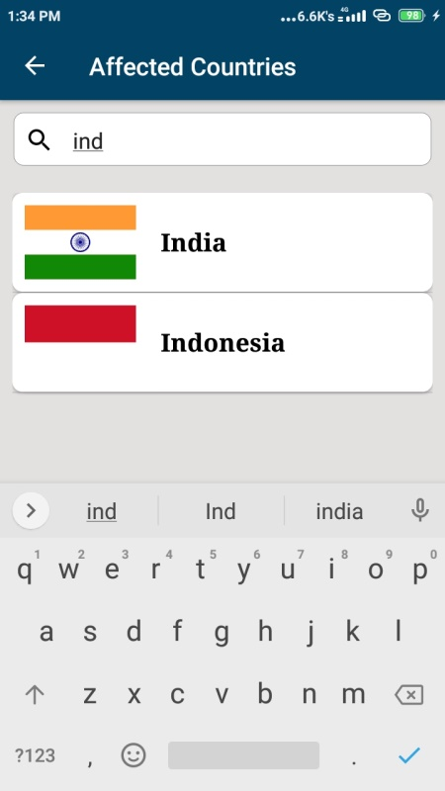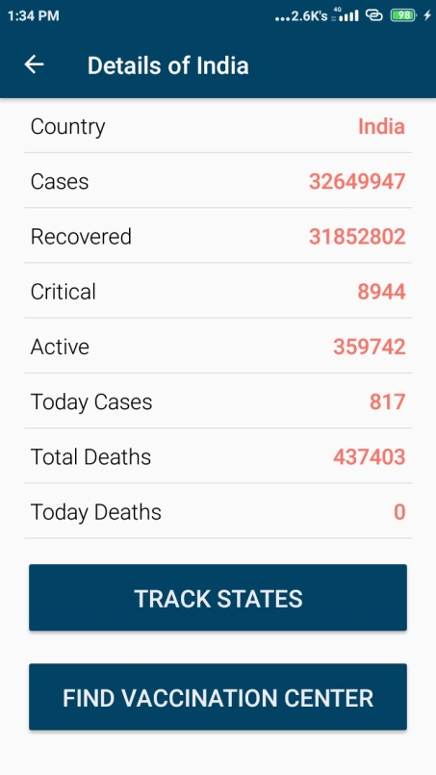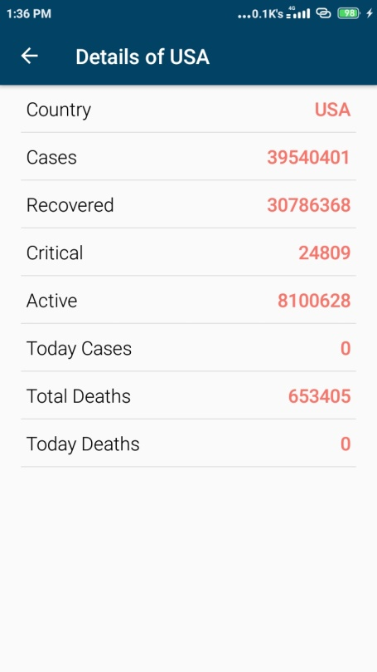

**Note:-**

* Here we can trace all the states of India only, but we can’t trace states of any other country.
* Here we can find vaccination centers of India only, but we can’t find vaccination centers of any other country.
* Here you can see that you can’t trace the states and vaccination centers of any other country.

**Track State Button:-** Here you can trace the states of India.

**Find vaccination centers:-** Here you can find vaccination centers according to the Pin code of your area.

**Front end Code XML of Affected Countries:**

<?xml version="1.0" encoding="utf-8"?>  
<LinearLayout xmlns:android="http://schemas.android.com/apk/res/android"  
 xmlns:tools="http://schemas.android.com/tools"  
 android:layout_width="match_parent"  
 android:layout_height="match_parent"  
 xmlns:app="http://schemas.android.com/apk/res-auto"  
 android:orientation="vertical"  
 tools:context=".DetailActivity">  
  
 <RelativeLayout  
 android:layout_width="match_parent"  
 android:layout_height="wrap_content"  
 android:layout_marginRight="25dp"  
 android:layout_marginLeft="25dp"  
 android:layout_marginTop="10dp"  
 android:layout_marginBottom="10dp">  
 <TextView  
 android:layout_width="wrap_content"  
 android:layout_height="wrap_content"  
 android:fontFamily="sans-serif-light"  
 android:text="@string/country"  
 android:textSize="18sp"  
 android:textColor="@color/color_black"  
 tools:ignore="RelativeOverlap" />  
 <TextView  
 android:layout_width="fill_parent"  
 android:layout_height="wrap_content"  
 android:text="@string/_0"  
 android:textSize="18sp"  
 android:id="@+id/tvCountry"  
 android:textAlignment="textEnd"  
 android:textColor="@color/color_one"  
 android:textStyle="bold"  
 android:fontFamily="sans-serif-light"  
 android:layout_alignParentEnd="true"/>  
  
 </RelativeLayout>  
 <View  
 android:layout_width="match_parent"  
 android:layout_height="1dp"  
 android:layout_marginLeft="20dp"  
 android:background="@color/color_two"  
 android:layout_marginRight="20dp" />  
 <RelativeLayout  
 android:layout_width="match_parent"  
 android:layout_height="wrap_content"  
 android:layout_marginRight="25dp"  
 android:layout_marginLeft="25dp"  
 android:layout_marginTop="10dp"  
 android:layout_marginBottom="10dp">  
 <TextView  
 android:layout_width="wrap_content"  
 android:layout_height="wrap_content"  
 android:fontFamily="sans-serif-light"  
 android:text="@string/cases"  
 android:textColor="@color/color_black"  
 android:textSize="18sp"  
 tools:ignore="RelativeOverlap" />  
  
 <TextView  
 android:id="@+id/tvCases"  
 android:layout_width="fill_parent"  
 android:layout_height="wrap_content"  
 android:layout_alignParentEnd="true"  
 android:fontFamily="sans-serif-light"  
 android:text="@string/_0"  
 android:textAlignment="textEnd"  
 android:textColor="@color/color_one"  
 android:textSize="18sp"  
 android:textStyle="bold" />  
  
 </RelativeLayout>  
 <View  
 android:layout_width="match_parent"  
 android:layout_height="1dp"  
 android:layout_marginLeft="20dp"  
 android:background="@color/color_two"  
 android:layout_marginRight="20dp" />  
 <RelativeLayout  
 android:layout_width="match_parent"  
 android:layout_height="wrap_content"  
 android:layout_marginRight="25dp"  
 android:layout_marginLeft="25dp"  
 android:layout_marginTop="10dp"  
 android:layout_marginBottom="10dp">  
 <TextView  
 android:layout_width="wrap_content"  
 android:layout_height="wrap_content"  
 android:fontFamily="sans-serif-light"  
 android:text="@string/recovered"  
 android:textColor="@color/color_black"  
 android:textSize="18sp"  
 tools:ignore="RelativeOverlap" />  
  
 <TextView  
 android:id="@+id/tvRecovered"  
 android:layout_width="fill_parent"  
 android:layout_height="wrap_content"  
 android:layout_alignParentEnd="true"  
 android:fontFamily="sans-serif-light"  
 android:text="@string/_0"  
 android:textAlignment="textEnd"  
 android:textColor="@color/color_one"  
 android:textSize="18sp"  
 android:textStyle="bold" />  
  
 </RelativeLayout>  
 <View  
 android:layout_width="match_parent"  
 android:layout_height="1dp"  
 android:layout_marginLeft="20dp"  
 android:background="@color/color_two"  
 android:layout_marginRight="20dp" />  
 <RelativeLayout  
 android:layout_width="match_parent"  
 android:layout_height="wrap_content"  
 android:layout_marginRight="25dp"  
 android:layout_marginLeft="25dp"  
 android:layout_marginTop="10dp"  
 android:layout_marginBottom="10dp">  
 <TextView  
 android:layout_width="wrap_content"  
 android:layout_height="wrap_content"  
 android:fontFamily="sans-serif-light"  
 android:text="@string/critical"  
 android:textSize="18sp"  
 android:textColor="@color/color_black"  
 tools:ignore="RelativeOverlap" />  
  
 <TextView  
 android:id="@+id/tvCritical"  
 android:layout_width="fill_parent"  
 android:layout_height="wrap_content"  
 android:layout_alignParentEnd="true"  
 android:fontFamily="sans-serif-light"  
 android:text="@string/_0"  
 android:textAlignment="textEnd"  
 android:textColor="@color/color_one"  
 android:textSize="18sp"  
 android:textStyle="bold" />  
  
 </RelativeLayout>  
 <View  
 android:layout_width="match_parent"  
 android:layout_height="1dp"  
 android:layout_marginLeft="20dp"  
 android:background="@color/color_two"  
 android:layout_marginRight="20dp" />  
 <RelativeLayout  
 android:layout_width="match_parent"  
 android:layout_height="wrap_content"  
 android:layout_marginRight="25dp"  
 android:layout_marginLeft="25dp"  
 android:layout_marginTop="10dp"  
 android:layout_marginBottom="10dp">  
 <TextView  
 android:layout_width="wrap_content"  
 android:layout_height="wrap_content"  
 android:fontFamily="sans-serif-light"  
 android:text="@string/active"  
 android:textColor="@color/color_black"  
 android:textSize="18sp"  
 tools:ignore="RelativeOverlap" />  
 <TextView  
 android:layout_width="fill_parent"  
 android:layout_height="wrap_content"  
 android:text="@string/_0"  
 android:textSize="18sp"  
 android:id="@+id/tvActive"  
 android:textAlignment="textEnd"  
 android:textColor="@color/color_one"  
 android:textStyle="bold"  
 android:fontFamily="sans-serif-light"  
 android:layout_alignParentEnd="true"/>  
  
 </RelativeLayout>  
 <View  
 android:layout_width="match_parent"  
 android:layout_height="1dp"  
 android:layout_marginLeft="20dp"  
 android:background="@color/color_two"  
 android:layout_marginRight="20dp" />  
 <RelativeLayout  
 android:layout_width="match_parent"  
 android:layout_height="wrap_content"  
 android:layout_marginRight="25dp"  
 android:layout_marginLeft="25dp"  
 android:layout_marginTop="10dp"  
 android:layout_marginBottom="10dp">  
 <TextView  
 android:layout_width="wrap_content"  
 android:layout_height="wrap_content"  
 android:fontFamily="sans-serif-light"  
 android:text="@string/today_cases"  
 android:textSize="18sp"  
 android:textColor="@color/color_black"  
 tools:ignore="RelativeOverlap" />  
 <TextView  
 android:layout_width="fill_parent"  
 android:layout_height="wrap_content"  
 android:text="@string/_0"  
 android:textSize="18sp"  
 android:id="@+id/tvTodayCases"  
 android:textAlignment="textEnd"  
 android:textColor="@color/color_one"  
 android:textStyle="bold"  
 android:fontFamily="sans-serif-light"  
 android:layout_alignParentEnd="true"/>  
  
 </RelativeLayout>  
 <View  
 android:layout_width="match_parent"  
 android:layout_height="1dp"  
 android:layout_marginLeft="20dp"  
 android:background="@color/color_two"  
 android:layout_marginRight="20dp" />  
 <RelativeLayout  
 android:layout_width="match_parent"  
 android:layout_height="wrap_content"  
 android:layout_marginRight="25dp"  
 android:layout_marginLeft="25dp"  
 android:layout_marginTop="10dp"  
 android:layout_marginBottom="10dp">  
 <TextView  
 android:layout_width="wrap_content"  
 android:layout_height="wrap_content"  
 android:fontFamily="sans-serif-light"  
 android:text="@string/total_deaths"  
 android:textColor="@color/color_black"  
 android:textSize="18sp"  
 tools:ignore="RelativeOverlap" />  
 <TextView  
 android:layout_width="fill_parent"  
 android:layout_height="wrap_content"  
 android:text="@string/_0"  
 android:textSize="18sp"  
 android:id="@+id/tvTotalDeaths"  
 android:textAlignment="textEnd"  
 android:textColor="@color/color_one"  
 android:textStyle="bold"  
 android:fontFamily="sans-serif-light"  
 android:layout_alignParentEnd="true"/>  
  
 </RelativeLayout>  
 <View  
 android:layout_width="match_parent"  
 android:layout_height="1dp"  
 android:layout_marginLeft="20dp"  
 android:background="@color/color_two"  
 android:layout_marginRight="20dp" />  
 <RelativeLayout  
 android:layout_width="match_parent"  
 android:layout_height="wrap_content"  
 android:layout_marginRight="25dp"  
 android:layout_marginLeft="25dp"  
 android:layout_marginTop="10dp"  
 android:layout_marginBottom="10dp">  
 <TextView  
 android:layout_width="wrap_content"  
 android:layout_height="wrap_content"  
 android:fontFamily="sans-serif-light"  
 android:text="@string/today_deaths"  
 android:textSize="18sp"  
 android:textColor="@color/color_black"  
 tools:ignore="RelativeOverlap" />  
 <TextView  
 android:layout_width="fill_parent"  
 android:layout_height="wrap_content"  
 android:text="@string/_0"  
 android:textSize="18sp"  
 android:id="@+id/tvTodayDeaths"  
 android:textAlignment="textEnd"  
 android:textColor="@color/color_one"  
 android:textStyle="bold"  
 android:fontFamily="sans-serif-light"  
 android:layout_alignParentEnd="true"/>  
  
 </RelativeLayout>  
 <View  
 android:layout_width="match_parent"  
 android:layout_height="1dp"  
 android:layout_marginLeft="20dp"  
 android:background="@color/color_two"  
 android:layout_marginRight="20dp" />  
  
 <Button  
 android:id="@+id/state_wise_cases_btn"  
 android:layout_width="match_parent"  
 android:layout_height="wrap_content"  
 android:layout_marginTop="15sp"  
 android:layout_marginStart="20sp"  
 android:layout_marginEnd="20sp"  
 android:backgroundTint="@color/colorPrimary"  
 android:text="@string/track_states"  
 android:visibility="gone"  
 android:textColor="@color/color_white"  
 android:textSize="20sp"  
 android:elevation="3dp"  
 android:padding="20dp"  
 tools:targetApi="lollipop" />  
  
 <Button  
 android:id="@+id/find_vaccination_center_btn"  
 android:layout_width="match_parent"  
 android:layout_height="wrap_content"  
 android:layout_marginTop="15sp"  
 android:layout_marginStart="20sp"  
 android:layout_marginEnd="20sp"  
 android:backgroundTint="@color/colorPrimary"  
 android:text="@string/find_vaccination_center"  
 android:textColor="@color/color_white"  
 android:visibility="gone"  
 android:textSize="20sp"  
 android:elevation="3dp"  
 android:padding="20dp"  
 tools:targetApi="lollipop" />  
  
  
</LinearLayout>

**Back end Code Java of Affected Countries:**

package com.zibran.covid19tracker**;**import androidx.annotation.NonNull**;**import androidx.appcompat.app.AppCompatActivity**;**import android.content.Intent**;**import android.os.Bundle**;**import android.view.MenuItem**;**import android.view.View**;**import android.view.WindowManager**;**import android.widget.Button**;**import android.widget.TextView**;**import java.util.Objects**;**public class DetailActivity extends AppCompatActivity {  
 TextView tvCountry**,**tvCases **,** tvRecovered **,** tvCritical **,** tvActive **,**tvTodayCases **,** tvTotalDeaths **,** tvTodayDeaths**;** Button stateWiseBtn**,**findVaccinationCenterBtn**;** String country**;** @Override  
 protected void onCreate(Bundle savedInstanceState) {  
 super.onCreate(savedInstanceState)**;** setContentView(R.layout.*activity_detail*)**;** Intent intent=getIntent()**;** int positionCountry = intent.getIntExtra("position"**, 0**)**;** Objects.*requireNonNull*(getSupportActionBar()).setTitle("Details of "+  
 AffectedCountries.*countryModelsList*.get(positionCountry).getCountry())**;** getSupportActionBar().setDisplayHomeAsUpEnabled(true)**;** getSupportActionBar().setDisplayShowHomeEnabled(true)**;** tvCountry=findViewById(R.id.*tvCountry*)**;** tvCases=findViewById(R.id.*tvCases*)**;** tvRecovered=findViewById(R.id.*tvRecovered*)**;** tvCritical=findViewById(R.id.*tvCritical*)**;** tvActive=findViewById(R.id.*tvActive*)**;** tvTodayCases=findViewById(R.id.*tvTodayCases*)**;** tvTotalDeaths=findViewById(R.id.*tvTotalDeaths*)**;** tvTodayDeaths=findViewById(R.id.*tvTodayDeaths*)**;** stateWiseBtn =findViewById(R.id.*state_wise_cases_btn*)**;** findVaccinationCenterBtn= findViewById(R.id.*find_vaccination_center_btn*)**;** country = AffectedCountries.*countryModelsList*.get(positionCountry).getCountry()**;** if (country.equals("India")){  
 stateWiseBtn.setVisibility(View.*VISIBLE*)**;** findVaccinationCenterBtn.setVisibility(View.*VISIBLE*)**;** }  
  
 tvCountry.setText(AffectedCountries.*countryModelsList*.get(positionCountry).getCountry())**;** tvCases.setText(AffectedCountries.*countryModelsList*.get(positionCountry).getCases())**;** tvRecovered.setText(AffectedCountries.*countryModelsList*.get(positionCountry).getRecoverd())**;** tvCritical.setText(AffectedCountries.*countryModelsList*.get(positionCountry).getCritical())**;** tvActive.setText(AffectedCountries.*countryModelsList*.get(positionCountry).getActive())**;** tvTodayCases.setText(AffectedCountries.*countryModelsList*.get(positionCountry).getTodayCases())**;** tvTotalDeaths.setText(AffectedCountries.*countryModelsList*.get(positionCountry).getDeaths())**;** tvTodayDeaths.setText(AffectedCountries.*countryModelsList*.get(positionCountry).getTodayDeaths())**;** stateWiseBtn.setOnClickListener(view ->   
 startActivity(new Intent(getApplicationContext()**,**StateRVActivity.class)))**;** findVaccinationCenterBtn.setOnClickListener(view ->   
 startActivity(new Intent(getApplicationContext()**,**FindVaccinationCenterActivity.class)))**;** }  
 @Override  
 public boolean onOptionsItemSelected(@NonNull MenuItem item) {  
 if(item.getItemId()==android.R.id.*home*)  
 finish()**;** return super.onOptionsItemSelected(item)**;** }  
}

**TRACK STATE**

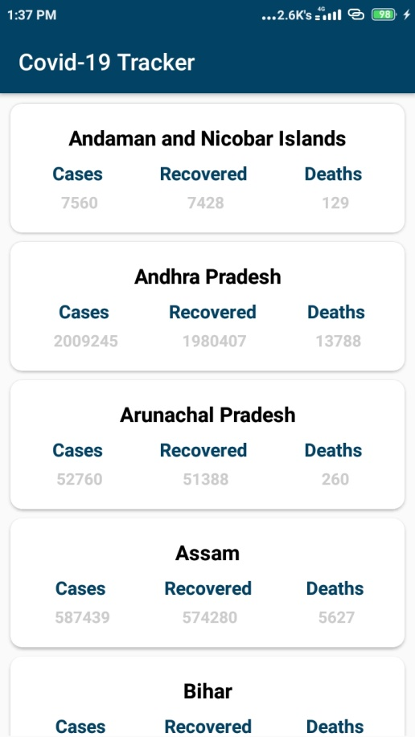

* When you click on the track states button you will be on this screen shown above.
* Here all the states of India are shown on this screen.
* Here you can see how many cases are in the state.
* Here you can see the total how many cases, how many recovered and how many deaths in which state.

**Front end Code XML of Track States:**

<?xml version="1.0" encoding="utf-8"?>  
<androidx.constraintlayout.widget.ConstraintLayout xmlns:android="http://schemas.android.com/apk/res/android"  
 xmlns:app="http://schemas.android.com/apk/res-auto"  
 xmlns:tools="http://schemas.android.com/tools"  
 android:layout_width="match_parent"  
 android:layout_height="match_parent"  
 tools:context=".StateRVActivity">  
  
 <androidx.recyclerview.widget.RecyclerView  
 android:id="@+id/state_RV"  
 android:layout_width="0dp"  
 android:layout_height="0dp"  
 android:layout_marginStart="1dp"  
 android:layout_marginTop="1dp"  
 android:layout_marginEnd="1dp"  
 android:layout_marginBottom="1dp"  
 app:layout_constraintBottom_toBottomOf="parent"  
 app:layout_constraintEnd_toEndOf="parent"  
 app:layout_constraintStart_toStartOf="parent"  
 app:layout_constraintTop_toTopOf="parent" />  
</androidx.constraintlayout.widget.ConstraintLayout>

**Back end Code Java of Track States:**

package com.zibran.covid19tracker**;**import android.annotation.SuppressLint**;**import android.app.Dialog**;**import android.os.Build**;**import android.os.Bundle**;**import android.util.Log**;**import android.view.WindowManager**;**import android.widget.LinearLayout**;**import androidx.appcompat.app.AppCompatActivity**;**import androidx.recyclerview.widget.LinearLayoutManager**;**import androidx.recyclerview.widget.RecyclerView**;**import com.android.volley.Request**;**import com.android.volley.RequestQueue**;**import com.android.volley.toolbox.JsonObjectRequest**;**import com.android.volley.toolbox.Volley**;**import com.zibran.covid19tracker.adapters.StateRVAdapter**;**import com.zibran.covid19tracker.models.StateModel**;**import org.json.JSONArray**;**import org.json.JSONException**;**import org.json.JSONObject**;**import java.util.ArrayList**;**import java.util.List**;**public class StateRVActivity extends AppCompatActivity {  
  
 List<StateModel> stateModelList**;** StateRVAdapter stateRVAdapter**;** RecyclerView recyclerView**;** Dialog stateDialog**;** @SuppressLint("UseCompatLoadingForDrawables")  
 @Override  
 protected void onCreate(Bundle savedInstanceState) {  
 super.onCreate(savedInstanceState)**;** setContentView(R.layout.*activity_state_rvactivity*)**;** recyclerView = findViewById(R.id.*state_RV*)**;** LinearLayoutManager layoutManager = new LinearLayoutManager(this)**;** layoutManager.setOrientation(RecyclerView.*VERTICAL*)**;** recyclerView.setLayoutManager(layoutManager)**;** stateModelList = new ArrayList<>()**;** stateDialog = new Dialog(this)**;** stateDialog.setContentView(R.layout.*loading_dialog*)**;** stateDialog.getWindow().setLayout(LinearLayout.LayoutParams.*WRAP_CONTENT***,** LinearLayout.LayoutParams.*WRAP_CONTENT*)**;** if (Build.VERSION.*SDK_INT* >= Build.VERSION_CODES.*LOLLIPOP*) {  
 stateDialog.getWindow().setBackgroundDrawable(getDrawable(R.drawable.*progress_bg*))**;** }  
  
 stateDialog.setCancelable(false)**;** fetchData()**;** }  
  
 private void fetchData() {  
 stateDialog.show()**;** JsonObjectRequest request = new JsonObjectRequest(Request.Method.*GET***,** "https://api.rootnet.in/covid19-in/stats/latest"**,** null**,** response -> {  
 Log.*e*("ddeeeeeeee"**,** response.toString())**;** try {  
 JSONObject jsonObject**;** jsonObject = response.getJSONObject("data")**;** JSONArray jsonArray = jsonObject.getJSONArray("regional")**;** for (int i = **0;** i < jsonArray.length()**;** i++) {  
 JSONObject object = jsonArray.getJSONObject(i)**;** String state = object.getString("loc")**;** int cases = object.getInt("totalConfirmed")**;** int recovered = object.getInt("discharged")**;** int deaths = object.getInt("deaths")**;** stateModelList.add(new StateModel(state**,** recovered**,** deaths**,** cases))**;** Log.*e*("ddddd"**,** stateModelList.toString())**;** }  
 stateDialog.dismiss()**;** stateRVAdapter = new StateRVAdapter(stateModelList**,** this)**;** recyclerView.setAdapter(stateRVAdapter)**;** stateRVAdapter.notifyDataSetChanged()**;** } catch (JSONException e) {  
 e.printStackTrace()**;** }  
 }**,** error -> {  
  
 })**;** RequestQueue queue = Volley.*newRequestQueue*(this)**;** queue.add(request)**;** }  
}

**FIND VACCINATION CENTERS**

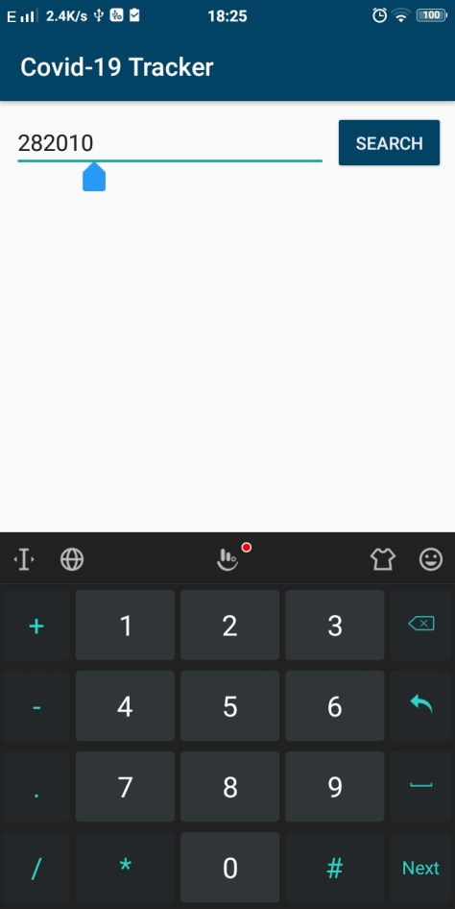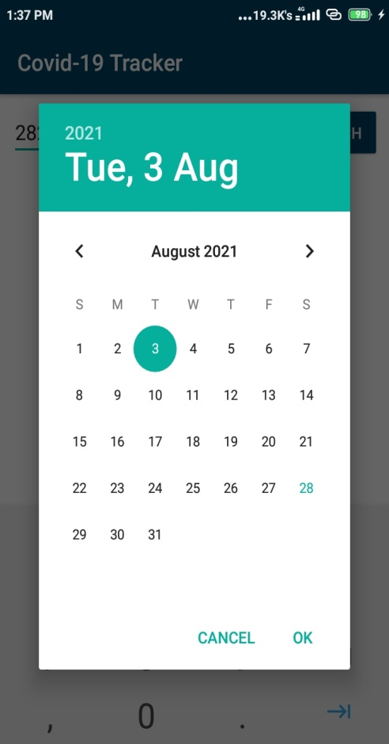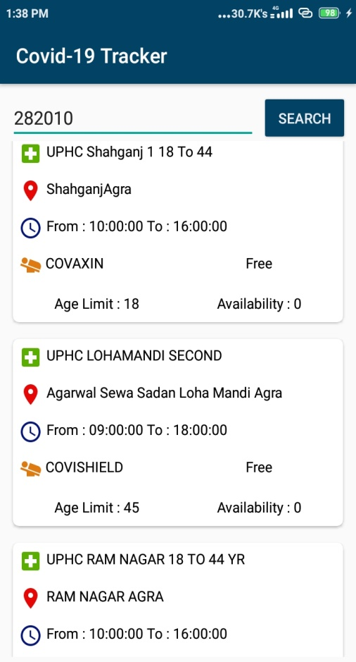

* Here you can find vaccination centers according to the Pin code and date.
* But you can’t book a vaccination center for vaccination.

**Front end Code XML of Find vaccination Centers:**

<?xml version="1.0" encoding="utf-8"?>  
<androidx.constraintlayout.widget.ConstraintLayout xmlns:android="http://schemas.android.com/apk/res/android"  
 xmlns:app="http://schemas.android.com/apk/res-auto"  
 xmlns:tools="http://schemas.android.com/tools"  
 android:layout_width="match_parent"  
 android:layout_height="match_parent"  
 android:layout_margin="5dp"  
 tools:context=".FindVaccinationCenterActivity">  
  
 <EditText  
 android:id="@+id/idEditPinCode"  
 android:layout_width="0dp"  
 android:layout_height="wrap_content"  
 android:hint="Enter pincode"  
 android:inputType="number"  
 android:layout_margin="5dp"  
 app:layout_constraintEnd_toStartOf="@+id/idBtnSearch"  
 app:layout_constraintStart_toStartOf="parent"  
 app:layout_constraintTop_toTopOf="parent" />  
  
 <Button  
 android:id="@+id/idBtnSearch"  
 android:layout_width="wrap_content"  
 android:layout_height="wrap_content"  
 android:layout_alignParentEnd="true"  
 android:layout_margin="3dp"  
 android:backgroundTint="@color/colorPrimary"  
 android:padding="5dp"  
 android:text="@string/search"  
 android:elevation="3sp"  
 android:textColor="@color/color_white"  
 app:layout_constraintBottom_toBottomOf="@+id/idEditPinCode"  
 app:layout_constraintEnd_toEndOf="parent"  
 app:layout_constraintTop_toTopOf="@+id/idEditPinCode"  
 tools:targetApi="lollipop" />  
  
 <androidx.recyclerview.widget.RecyclerView  
 android:id="@+id/idRV"  
 android:layout_width="match_parent"  
 android:layout_height="0dp"  
 android:layout_below="@id/idEditPinCode"  
 app:layout_constraintBottom_toBottomOf="parent"  
 app:layout_constraintTop_toBottomOf="@+id/idEditPinCode" />  
  
 <ProgressBar  
 android:id="@+id/idLoadingBar"  
 android:layout_width="wrap_content"  
 android:layout_height="wrap_content"  
 android:layout_centerInParent="true"  
 android:visibility="gone"  
 app:layout_constraintBottom_toBottomOf="@+id/idRV"  
 app:layout_constraintEnd_toEndOf="@+id/idRV"  
 app:layout_constraintStart_toStartOf="parent"  
 app:layout_constraintTop_toTopOf="@+id/idRV" />  
  
</androidx.constraintlayout.widget.ConstraintLayout>

**Back end Code Java of Find vaccination Centers:**

package com.zibran.covid19tracker**;**import androidx.appcompat.app.AppCompatActivity**;**import androidx.recyclerview.widget.LinearLayoutManager**;**import androidx.recyclerview.widget.RecyclerView**;**import android.app.DatePickerDialog**;**import android.os.Bundle**;**import android.view.View**;**import android.view.WindowManager**;**import android.widget.Button**;**import android.widget.DatePicker**;**import android.widget.EditText**;**import android.widget.ProgressBar**;**import android.widget.Toast**;**import com.android.volley.Request**;**import com.android.volley.RequestQueue**;**import com.android.volley.toolbox.JsonObjectRequest**;**import com.android.volley.toolbox.Volley**;**import com.zibran.covid19tracker.adapters.CenterRVAdapter**;**import com.zibran.covid19tracker.models.CenterRVModel**;**import org.json.JSONArray**;**import org.json.JSONException**;**import org.json.JSONObject**;**import java.util.ArrayList**;**import java.util.Calendar**;**import java.util.List**;**public class FindVaccinationCenterActivity extends AppCompatActivity {  
  
 private EditText pinCodeEdt**;** private RecyclerView centerRV**;** private ProgressBar loadingBar**;** private List<CenterRVModel> centerRVModelList**;** private CenterRVAdapter centerRVAdapter**;** @Override  
 protected void onCreate(Bundle savedInstanceState) {  
 super.onCreate(savedInstanceState)**;** setContentView(R.layout.*activity_find_vaccination_center*)**;** pinCodeEdt = findViewById(R.id.*idEditPinCode*)**;** Button searchBtn = findViewById(R.id.*idBtnSearch*)**;** centerRV = findViewById(R.id.*idRV*)**;** loadingBar = findViewById(R.id.*idLoadingBar*)**;** centerRVModelList = new ArrayList<>()**;** LinearLayoutManager layoutManager = new LinearLayoutManager(this)**;** centerRV.setLayoutManager(layoutManager)**;** centerRVAdapter = new CenterRVAdapter(centerRVModelList**,** this)**;** centerRV.setAdapter(centerRVAdapter)**;** searchBtn.setOnClickListener(view -> {  
 String pinCode = pinCodeEdt.getText().toString()**;** if (pinCode.length() != **6**) {  
 Toast.*makeText*(this**,** "Please Enter valid pin code"**,** Toast.*LENGTH_SHORT*).show()**;** } else {  
 centerRVModelList.clear()**;** Calendar calendar = Calendar.*getInstance*()**;** int year = calendar.get(Calendar.*YEAR*)**;** int month = calendar.get(Calendar.*MONTH*)**;** int day = calendar.get(Calendar.*DAY_OF_MONTH*)**;** DatePickerDialog pickerDialog = new DatePickerDialog(this**,** new DatePickerDialog.OnDateSetListener() {  
 @Override  
 public void onDateSet(DatePicker datePicker**,** int year**,** int month**,** int dayOfMonth) {  
 loadingBar.setVisibility(View.*VISIBLE*)**;** String dateStr = "" + dayOfMonth + "-" + (month + **1**) + "-" + year**;** getAppointmentDetails(pinCode**,** dateStr)**;** }  
 }**,** year**,** month**,** day)**;** pickerDialog.show()**;** }  
 })**;** }  
  
 private void getAppointmentDetails(String pinCode**,** String dateStr) {  
 JsonObjectRequest request = new JsonObjectRequest(Request.Method.*GET***,** "https://cdn-api.co-vin.in/api/v2/appointment/sessions/public/calendarByPin?pincode="   
 + pinCode + "&date=" + dateStr**,** null**,** response -> {  
 loadingBar.setVisibility(View.*GONE*)**;** try {  
 JSONArray jsonArray = response.getJSONArray("centers")**;** if (jsonArray.length() == **0**) {  
 Toast.*makeText*(this**,** "No Vaccination center available"**,** Toast.*LENGTH_SHORT*).show()**;** }  
 for (int i = **0;** i < jsonArray.length()**;** i++) {  
 JSONObject jsonObject = jsonArray.getJSONObject(i)**;** String centerName = jsonObject.getString("name")**;** String centerAddress = jsonObject.getString("address")**;** String centerFromTime = jsonObject.getString("from")**;** String centerToTime = jsonObject.getString("to")**;** String feeType = jsonObject.getString("fee_type")**;** JSONObject sessionObj = jsonObject.getJSONArray("sessions").getJSONObject(**0**)**;** int availabilityCapacity = sessionObj.getInt("available_capacity")**;** int ageLimit = sessionObj.getInt("min_age_limit")**;** String vaccineName = sessionObj.getString("vaccine")**;** centerRVModelList.add(new CenterRVModel(centerName**,** centerAddress**,** centerFromTime**,** centerToTime**,** feeType**,** ageLimit**,** vaccineName**,** availabilityCapacity))**;** }  
  
 centerRVAdapter.notifyDataSetChanged()**;** } catch (JSONException e) {  
 e.printStackTrace()**;** loadingBar.setVisibility(View.*GONE*)**;** }  
  
  
 }**,** error -> {  
 Toast.*makeText*(this**,** "Failed to get data"**,** Toast.*LENGTH_SHORT*).show()**;** loadingBar.setVisibility(View.*GONE*)**;** })**;** RequestQueue queue = Volley.*newRequestQueue*(this)**;** queue.add(request)**;** }  
}